Name: __________________________________________ Date:_______ Period:______

Trigonometry Test Review Ms. Cronin

**Trigonometry Test Review**

Part I: Multiple choice. Write the number of the correct choice on the line provided.

**_____ 1.** In which quadrant does a -285° angle lie?

**(1)** I **(2)** II **(3)** III **(4)** IV

**_____ 2.** Which angle is *not* coterminal with an angle that measures 300°?

**(1)** -420° **(2)** -300° **(3)** -60° **(4)** 660°

**_____ 3.** What is the reference angle for -512°?

**(1)** -208° **(2)** -28° **(3)** 28° **(4)** 280°

**_____ 4.** An angle of  radians lies in quadrant

**(1)** I **(2)** II **(3)** III **(4)** IV

**_____ 5.** The value of tan 315° is the same as the value of

**(1)** cos 0° **(2)** sin 90° **(3)** tan 135° **(4)** sin 180°

**_____ 6.** Express 330° in radian measure.

**(1)**  **(2) ** **(3) ** **(4) **

**Part II:** Basic Trigonometry. Find the value of *x*, the length of the side, or θ, the degree measure of the angle. Round answers to the nearest *hundredth*.

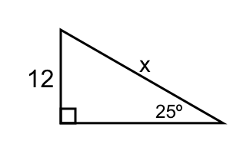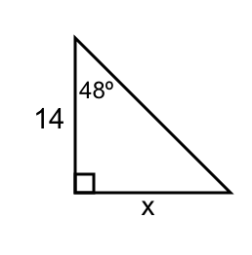

**7.**  **8.**

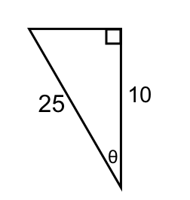

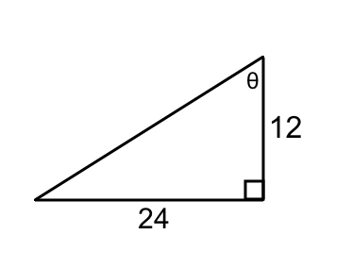**9.** **10.**

**Part III:** Coterminal Angles. For each angle in questions 11–13, find a coterminal angle that is between 0° and 360°.

**11.** 455° **12.** -160° **13.** 825°

**Part IV:** Unit Circle.

**14.** If sinθ < 0 and tanθ > 0, in which quadrant does θ lie?

**15.** In which quadrant does an angle of 260° lie? Is cos260° positive or negative?

**Part V:** Reference Angles.

For questions 16 and 17, find the reference angle of each given angle.

**16.** 145° **17.** 305°

**18.** Express sin145° as a function of a positive acute angle.

**Part VI:** Special Angles. Fill in the values of the trigonometric functions for each angle.

**19.**

|  |  |  |  |  |  |  |  |
| --- | --- | --- | --- | --- | --- | --- | --- |
| **θ** | **0°** | **30°** | **45°** | **60°** | **90°** | **180°** | **270°** |
| **sinθ** |  |  |  |  |  |  |  |
| **cosθ** |  |  |  |  |  |  |  |
| **tanθ** |  |  |  |  |  |  |  |

**Part VII:** Degrees and Radians.

**20.** Convert an angle of 210° into radians.

**21.** Convert an angle of  radians into degrees.