Physics Review

Multiple Choice
Identify the letter of the choice that best completes the statement or answers the question.

____ 1. One kilometer equals 1000 meters. What does the prefix kilo- mean?
a. | 1 | c. | 100
b. | 10 | d. | 1000

____ 2. A person walks 1 mile every day for exercise, leaving her front porch at 9:00 am. and returning to her front porch at 9:25 am. What is the total displacement of her daily walk?
a. | 1 mile | c. | 25 minutes
b. | 0 | d. | none of the above

____ 3. A ball is rolled uphill a distance of 5 meters before it slows, stops, and begins to roll back. The ball rolls downhill 9 meters before coming to rest against a tree. What is the magnitude of the ball’s displacement?
a. | 4 meters | c. | 14 meters
b. | 9 meters | d. | 45 meters

____ 4. Speed is the ratio of the distance an object moves to
a. | the amount of time needed to travel the distance.
b. | the direction the object moves.
c. | the displacement of the object.
d. | the motion of the object.

____ 5. Instantaneous speed is measured
a. | at the starting point.
b. | when the object reaches its destination.
c. | at a particular instant.
d. | over the duration of the trip.

____ 6. The slope of a line on a distance-time graph is
a. | distance. | c. | speed.
b. | time. | d. | displacement.

____ 7. A horizontal line on a distance-time graph means the object is
a. | moving at a constant speed. | c. | slowing down.
b. | moving faster. | d. | at rest.

____ 8. What is the speed of a bobsled whose distance-time graph indicates that it traveled 100 m in 25 s?
a. | 4 m/s | c. | 0.25 mph
b. | 2500 m/s | d. | 100 m/s

____ 9. The rate at which velocity changes is called
a. | speed. | c. | acceleration.
b. | vectors. | d. | motion.

____ 10. Objects in free fall near the surface of the Earth experience
a. | constant speed. | c. | constant acceleration.
b. | constant velocity. | d. | constant distance.

____ 11. Suppose you increase your walking speed from 1 m/s to 3 m/s in a period of 1 s. What is your acceleration?
a. | 2 m/s² | c. | 4 m/s²
b. | 5 m/s² | d. | 3 m/s²

____ 12. An object moving at 30 m/s takes 5 s to come to a stop. What is the object’s acceleration?
a. | 30 m/s² | c. | –6 m/s²
b. | –30 m/s² | d. | 6 m/s²

____ 13. The slope of a speed-time graph indicates
a. | direction. | c. | velocity.
b. | acceleration. | d. | speed.

____ 14. An object that is accelerating may be
a. | slowing down. | c. | changing direction.
b. | gaining speed. | d. | all of the above

____ 15. The SI unit of force is the
a. | joule. | c. | meter.
b. | kilogram. | d. | newton.

____ 16. Which of the following relationships is correct?
a. | 1 N = 1 kg | c. | 1 N = 1 kg·m/s
b. | 1 N = 1 kg·m | d. | 1 N = 1 kg·m/s²

____ 17. When an unbalanced force acts on an object,
a. | the object’s motion does not change. | c. | the weight of the object decreases.
b. | the object accelerates. | d. | the inertia of the object increases.

____ 18. When a pair of balanced forces acts on an object, the net force that results is
a. | greater in size than both forces combined.
b. | greater in size than one of the forces.
c. | equal in size to one of the forces.
d. | equal to zero.

____ 19. The property of matter that resists changes in motion is called
a. | friction. | c. | inertia.
b. | gravity. | d. | weight.

____ 20. According to Newton’s second law of motion, the acceleration of an object equals the net force acting on the object divided by the object’s
a. | mass. | c. | velocity.
b. | momentum. | d. | weight.

____ 21. If a force of 12 N is applied to an object with a mass of 2 kg, the object will accelerate at
a. | 0.17 m/s². | c. | 6 m/s².
b. | 24 m/s². | d. | 12 m/s².

____ 22. Your weight equals your
a. | mass.
b. | mass divided by the net force acting on you.
c. | mass times the acceleration due to gravity.
d. | mass times your speed.

____ 23. Newton’s third law of motion describes
a. | action and reaction forces. | c. | centripetal forces.
b. | balanced forces. | d. | net force.

____ 24. In which of the following are action and reaction forces involved?
a. | when a tennis racket strikes a tennis ball
b. | when stepping from a curb
c. | when rowing a boat
d. | all of the above

____ 25. The product of an object’s mass and velocity is its
a. | centripetal force. | c. | net force.
b. | momentum. | d. | weight.

____ 26. What is conserved when two objects collide in a closed system?
a. | acceleration | c. | speed
b. | momentum | d. | velocity

____ 27. What is the momentum of a 50-kilogram ice skater gliding across the ice at a speed of 5 m/s?
a. | 10 | c. | 50 kg
b. | 500 kg·m/s | d. | 250 kg·m/s

____ 28. Which universal force acts only on the protons and neutrons in a nucleus?
a. | electric | c. | magnetic
b. | gravitational | d. | strong nuclear

____ 29. The gravitational force between two objects increases as mass
a. | decreases or distance decreases. | c. | increases or distance decreases.
b. | decreases or distance increases. | d. | increases or distance increases.

____ 30. What is the SI unit of pressure?
a. | g/cm³ | c. | the newton
b. | m/s² | d. | the pascal

____ 31. A pressure of 70 N/m² equals
a. | 7 Pa. | c. | 700 Pa.
b. | 70 Pa. | d. | 7000 Pa.

____ 32. Which of the following is NOT possible?
a. | compressing 10 liters of oxygen gas into a 1-liter volume
b. | compressing 2 liters of water into a 1-liter volume
c. | filling a balloon using helium gas from a pressurized tank
d. | allowing 5 liters of compressed air to expand to a volume of 100 liters

____ 33. Atmospheric pressure is caused by
a. | air currents.
b. | the weight of the atmosphere above a particular location.
c. | clouds.
d. | the altitude above sea level.

____ 34. A brick weighs 26 N. Measured underwater, it weighs 11 N. What is the size of the buoyant force exerted by the water on the brick?
a. | 37 N | c. | 11 N
b. | 26 N | d. | 15 N

____ 35. The buoyant force on an object in a fluid is equal to the weight of the
a. | fluid. | c. | fluid displaced by the object.
b. | fluid surrounding the object. | d. | object.

____ 36. The relationship between buoyant force and weight of a displaced fluid was first stated by
a. | Archimedes. | c. | Newton.
b. | Bernoulli. | d. | Pascal.

____ 37. Which of the following substances will float in corn syrup? (The density of corn syrup is 1.38 g/cm³.)
a. | copper (8.9 g/cm³) | c. | iron (7.8 g/cm³)
b. | silver (10.5 g/cm³) | d. | glycerin (1.26 g/cm³)

____ 38. Which of the following substances will sink in glycerin? (The density of glycerin 1.26 g/cm³.)
a. | water (1.00 g/cm³) | c. | benzene (0.90 g/cm³)
b. | ethyl alcohol (0.81 g/cm³) | d. | aluminum (2.70 g/cm³)

____ 39. In which of the following is no work done?
a. | climbing stairs | c. | pushing a shopping cart
b. | lifting a book | d. | none of the above

____ 40. A force acting on an object does no work if
a. | a machine is used to move the object.
b. | the force is not in the direction of the object’s motion.
c. | the force is greater than the force of friction.
d. | the object accelerates.

____ 41. What is the unit of work?
a. | joule | c. | watt
b. | newton/meter | d. | all of the above

____ 42. If you exert a force of 10.0 N to lift a box a distance of 0.9 m, how much work do you do?
a. | 0.1 J | c. | 10.9 J
b. | 9.0 J | d. | 90.0 J

____ 43. If you perform 40 joules of work lifting a 10-N box from the floor to a shelf, how high is the shelf?
a. | 0.3 m | c. | 4.0 m
b. | 20 m | d. | 400 m

____ 44. The SI unit of power is the
a. | joule. | c. | newton-meter.
b. | newton. | d. | watt.

____ 45. The power of a machine measures
a. | its rate of doing work. | c. | the force it produces.
b. | its strength. | d. | the work it does.

____ 46. If you exert a force of 700 N to walk 6 m up a flight of stairs in 6 s, how much power do you use?
a. | 19 W | c. | 700 W
b. | 25,200 W | d. | 4200 W

____ 47. A 750-W motor might also be rated as a
a. | 0.5-horsepower motor.
b. | 1-horsepower motor.
c. | 2-horsepower motor.
d. | 10-horsepower motor.

____ 48. 3730 watts equals about how many horsepower?
a. | 5 | c. | 20
b. | 10 | d. | 30

____ 49. A machine is a device that can multiply
a. | force. | c. | work.
b. | power. | d. | all of the above

____ 50. How can you make the work output of a machine greater than the work input?
a. | by decreasing friction
b. | by increasing the input force
c. | by increasing the output distance
d. | none of the above

____ 51. The actual mechanical advantage of a machine
a. | cannot be less than 1.
b. | decreases as the input distance increases.
c. | increases with greater friction.
d. | is less than the ideal mechanical advantage of the machine.

____ 52. If you know the input distance and output distance of a machine, which of the following can you calculate?
a. | work
b. | actual mechanical advantage
c. | efficiency
d. | ideal mechanical advantage

____ 53. If you have to apply 40 N of force on a crowbar to lift a rock that weights 400 N, what is the actual mechanical advantage of the crowbar?
a. | 0.1 | c. | 360
b. | 10 | d. | 16,000

____ 54. The efficiency of a machine is always less than 100 percent because
a. | a machine cannot have an IMA greater than 1.
b. | some work input is lost to friction.
c. | the work input is too small.
d. | the work output is too great.

____ 55. A mechanical device requires 420 J of work to do 230 J of work in lifting a crate. What is the efficiency of the device?
a. | 0.5% | c. | 55%
b. | 190% | d. | 183%

____ 56. A motor with an efficiency of 75 percent must supply 240 J of useful work. What amount of work must be supplied to the motor?
a. | 75 J | c. | 320 J
b. | 180 J | d. | 420 J

____ 57. The ideal mechanical advantage of a pulley system is equal to the
a. | distance the load has to move.
b. | length of the rope.
c. | number of rope segments supporting the load.
d. | weight of the object being lifted.

____ 58. Work is a transfer of
a. | energy. | c. | mass.
b. | force. | d. | motion.

____ 59. What is transferred by a force moving an object through a distance?
a. | force | c. | motion
b. | mass | d. | energy

____ 60. The energy of motion is called
a. | kinetic energy. | c. | thermal energy.
b. | potential energy. | d. | work.

____ 61. A small 20-kilogram canoe is floating downriver at a speed of 2 m/s. What is the canoe’s kinetic energy?
a. | 22 J | c. | 80 J
b. | 40 J | d. | 400 J

____ 62. A 13-kg sled is moving at a speed of 3.0 m/s. At which of the following speeds will the sled have twice as much kinetic energy?
a. | 1.5 m/s | c. | 6 m/s
b. | 4.2 m/s | d. | 9 m/s

____ 63. An object’s gravitational potential energy is NOT directly related to which of the following?
a. | its height relative to a reference level | c. | its speed
b. | its mass | d. | the acceleration due to gravity

____ 64. Why is the gravitational potential energy of an object 1 meter above the moon’s surface less than its potential energy 1 meter above Earth’s surface?
a. | The object’s mass is less on the moon.
b. | The object’s weight is more on the moon.
c. | The object’s acceleration due to gravity is less on the moon.
d. | both a and c

____ 65. A 4-kilogram cat is resting on top of a bookshelf that is 3 meters high. What is the cat’s gravitational potential energy relative to the floor if the acceleration due to gravity is 9.8 m/s²?
a. | 7 J | c. | 29 J
b. | 12 J | d. | 118 J

____ 66. Which of the following statements is true according to the law of conservation of energy?
a. | Energy cannot be created.
b. | Energy cannot be destroyed.
c. | Energy can be converted from one form to another.
d. | all of the above

____ 67. If no friction acts on a diver during a dive, then which of the following statements is true?
a. | The total mechanical energy of the system increases.
b. | Potential energy can be converted into kinetic energy but not vice versa.
c. | (KE+ PE)_{beginning} = (KE + PE)_{end}
d. | all of the above

____ 68. What type of current is produced by a battery?
a. | parallel current | c. | direct current
b. | alternating current | d. | potential current

____ 69. The type of current in your school is mostly
a. | direct current. | c. | series current.
b. | alternating current. | d. | produced by batteries.

____ 70. Which of the following materials allows charges to flow easily?
a. | glass | c. | an electrical conductor
b. | wood | d. | an electrical insulator

____ 71. Resistance is affected by a material’s
a. | thickness. | c. | temperature.
b. | length. | d. | all of the above

____ 72. Which of the following would reduce the resistance of a metal wire?
a. | increasing its thickness | c. | increasing its length
b. | increasing its temperature | d. | all of the above

____ 73. What is the difference in electrical potential energy between two places in an electric field?
a. | current | c. | potential difference
b. | resistance | d. | induction

____ 74. Which of the following is maintained across the terminals of a battery?
a. | a potential difference | c. | an electric charge
b. | a voltage drop | d. | both A and B

____ 75. The current in a hair dryer measures 15.0 amps. The resistance of the hair dryer is 8 ohms. What is the voltage?
a. | 120 V | c. | 7 V
b. | 0.5 V | d. | 1800 V

____ 76. Which of the following represents Ohm’s law?
a. | I V R | c. | R V I
b. | V I R | d. | V I R

____ 77. How many paths through which charge can flow would be shown in a circuit diagram of a series circuit?
a. | one | c. | none
b. | two or more | d. | more information is needed

____ 78. Most of the circuits in your home are
a. | series circuits. | c. | reversible circuits.
b. | parallel circuits. | d. | closed circuits.

____ 79. What is the unit of electric power?
a. | ampere | c. | watt
b. | volt | d. | ohm

Completion
Complete each sentence or statement.

80. The SI unit for measuring ____________________ is the meter.

81. Speed is measured in units of _________________________.

82. 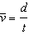 is the equation that defines _________________________.

83. The difference between speed and velocity is that velocity indicates the ____________________ of motion and speed does not.

84. Freely falling objects accelerate at 9.8 m/s² because the force of ____________________ acts on them.

85. The acceleration of a moving object is calculated by dividing the change in ____________________ by the time over which the change occurs.

86. A push or pull is an example of a(an) ____________________.

87. The type of force measured by a grocery store spring scale is ____________________.

88. During a head-on auto collision, ____________________ causes a passenger in the front seat to continue moving ____________________.

89. The unit g/cm³ is often used to express ____________________.

90. The weight of an object that sinks in a fluid is ____________________ than the buoyant force acting on it.

91. The SI unit of work is the ____________________.

92. The rate at which work is done is called ____________________.

93. The SI unit of power is the ____________________.

94. The watt and the horsepower are both units of ____________________.

95. A machine is a device that changes a(an) ____________________.

96. The force that is exerted on a machine is called the ____________________ force.

97. The _________________________ of a machine is the number of times that the machine increases the input force.

98. The mechanical efficiency of any machine is always ____________________ than 100 percent.

99. Energy of an object increases when ____________________ is done on the object.

100. Energy and work are measured in the SI unit called the ____________________.

101. If the ____________________ of an object doubles, its kinetic energy doubles.

102. The kinetic energy of an object is proportional to the square of its ____________________.

103. Energy that is stored due to position or shape is called ____________________ energy.

104. The SI unit of electric current is the ____________________.

105. The SI unit of resistance is the ____________________.

106. Potential difference is measured in _________________________.

107. A complete path through which charge can flow is an electric ____________________.

108. To calculate power, multiply voltage measured in ____________________ by ____________________ measured in amps.

109. The transfer of excess charge through a conductor to Earth is called ____________________.

Short Answer

110. Which is the most suitable SI unit for expressing the speed of a race car?

111. What is the significance of the slope in a distance-time graph?

112. What types of changes in motion cause acceleration?

113. 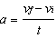 is the equation for calculating the acceleration of an object. Write out the relationship shown in the equation, using words.

114. A billiard ball with a momentum of 20 kg·m/s strikes a second ball at rest and comes to a complete stop. What is the change in momentum of the second ball?

115. How is the weight of water displaced by a floating cork related to the buoyant force on the cork?

116. How are density and buoyancy related?

117. Compare the weight of an object to the buoyant force acting on it if the object sinks in the fluid.

118. How is work done when you lift a book?

119. Why don’t you do work as you hold a book motionless over your head?

120. What are the two general types of energy that can be used to classify many forms of energy?

Problem

121. During a race, a runner runs at a speed of 6 m/s. 2 seconds later, she is running at a speed of 10 m/s. What is the runner’s acceleration? Show your work.

122. If you ride your bike at an average speed of 4 km/h and need to travel a total distance of 28 km, how long will it take you to reach your destination? Show your work.

123. A tow truck exerts a net horizontal force of 1050 N on an 760-kilogram car. What is the acceleration of the car during this time? Show your work.

124. The mass of a newborn baby is 3.5 kilograms. What is the baby’s weight? (The acceleration due to gravity at Earth’s surface is 9.8 m/s².) Show your work.

125. A 38-kilogram canoe broke free of its dock and is now floating downriver at a speed of 2.2 m/s. What is the canoe’s momentum? Show your work.

126. A small engine causes a 0.3-kg model airplane to accelerate at a rate of 11 m/s². What is the net force on the model airplane? Show your work.

127. A worker uses a cart to move a load of bricks weighing 680 N a distance of 10 m across a parking lot. If he pushes the cart with a constant force of 209 N, what amount of work does he do? Show your work.

128. A girl lifts a 160-N load a height of 1 m in a time of 0.5 s. What power does the girl produce? Show your work.

129. The input force of a pulley system must move 8.0 m to lift a 3000-N engine a distance of 2.0 m. What is the IMA of the system? Show your work.

130. A 20-N force applied to the handle of a door produces a 44-N output force. What is the AMA of the handle? Show your work.

131. A force of 11 N is applied to the handle of a screwdriver being used to pry off the lid of a paint can. As the input force moves through a distance 0.3 m, the screwdriver does 3 J of work on the lid. What is the efficiency of the screwdriver? Show your work.

132. What is the kinetic energy of a 72.0-kg sky diver falling at a terminal velocity of 79.0 m/s? Show your work.

Other

USING SCIENCE SKILLS

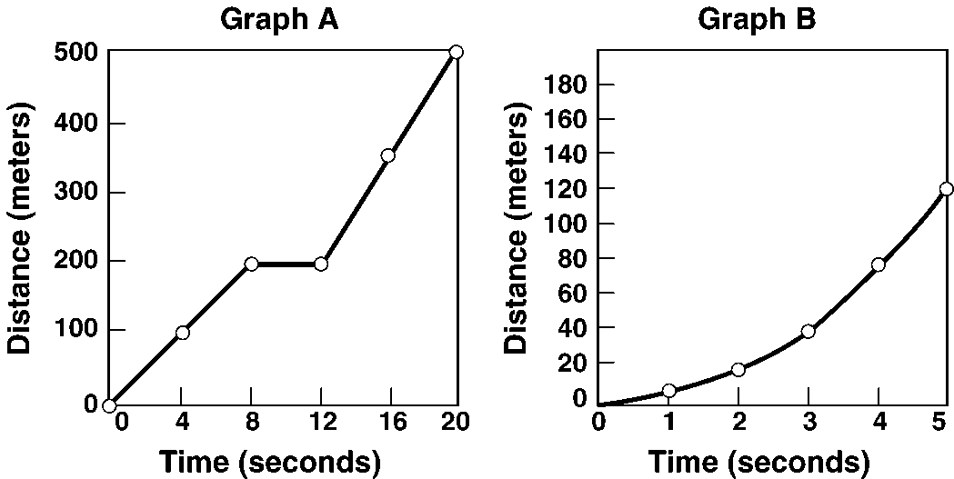

Figure 11-2

133. Calculating Using Graph A in Figure 11-2, calculate the average speed of the object in motion from 12 s to 20 s. Explain your calculation.

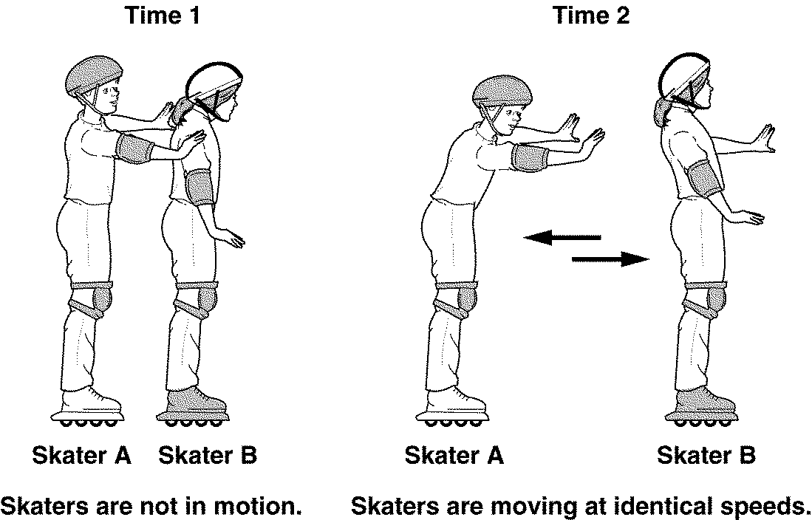

Figure 12-3

134. Interpreting Graphics In Figure 12-3, what is the momentum of each skater at Time 1?

135. Comparing and Contrasting In Figure 12-3, compare the size and direction of the momentums of both skaters immediately after the push shown at Time 2.

136. Interpreting Graphics In Figure 12-3, describe the motion of Skater B after Skater A pushes her.

137. Applying Concepts In Figure 12-3, if Skater A is pushing Skater B, why does Skater A move?

USING SCIENCE SKILLS

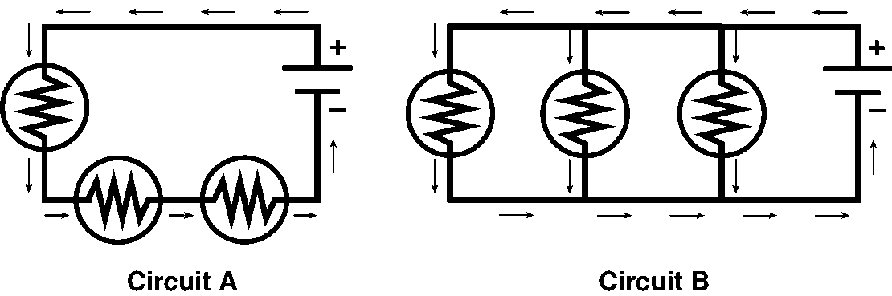

Figure 20-2

138. Classifying Are both circuits in Figure 20-2 series circuits? Explain your answer.
Physics Review
Answer Section

MULTIPLE CHOICE

1. ANS: D

2. ANS: B

3. ANS: A

4. ANS: A

5. ANS: C

6. ANS: C

7. ANS: D

8. ANS: A

9. ANS: C

10. ANS: C

11. ANS: A

12. ANS: C

13. ANS: B

14. ANS: D

15. ANS: D

16. ANS: D

17. ANS: B

18. ANS: D

19. ANS: C

20. ANS: A

21. ANS: C

22. ANS: C

23. ANS: A

24. ANS: D

25. ANS: B

26. ANS: B

27. ANS: D

28. ANS: D

29. ANS: C

30. ANS: D

31. ANS: B

32. ANS: B

33. ANS: B

34. ANS: D

35. ANS: C

36. ANS: A

37. ANS: D

38. ANS: D

39. ANS: D

40. ANS: B

41. ANS: A

42. ANS: B

43. ANS: C

44. ANS: D

45. ANS: A

46. ANS: C

47. ANS: B

48. ANS: A

49. ANS: A

50. ANS: D

51. ANS: D

52. ANS: D

53. ANS: B

54. ANS: B

55. ANS: C

56. ANS: C

57. ANS: C

58. ANS: A

59. ANS: D

60. ANS: A

61. ANS: B

62. ANS: B

63. ANS: C

64. ANS: C

65. ANS: D

66. ANS: D

67. ANS: C

68. ANS: C

69. ANS: B

70. ANS: C

71. ANS: D

72. ANS: A

73. ANS: C

74. ANS: D

75. ANS: A

76. ANS: B

77. ANS: A

78. ANS: B

79. ANS: C

COMPLETION

80. ANS:
distance or
length

81. ANS: meters per second

82. ANS: average speed

83. ANS: direction

84. ANS: gravity

85. ANS:
speed or
velocity

86. ANS: force

87. ANS: weight

88. ANS: inertia, forward

89. ANS: density

90. ANS: greater

91. ANS: joule

92. ANS: power

93. ANS: watt

94. ANS: power

95. ANS: force

96. ANS: input

97. ANS: mechanical advantage

98. ANS: less

99. ANS: work

100. ANS: joule

101. ANS: mass

102. ANS: speed

103. ANS: potential

104. ANS:
ampere
amp

105. ANS: ohm

106. ANS:
volts or
joules per coulomb

107. ANS: circuit

108. ANS: volts, current

109. ANS: grounding

SHORT ANSWER

110. ANS:
m/s

111. ANS:
The slope is the change in distance divided by the change in time, which gives speed.

112. ANS:
changes in speed, direction, or both

113. ANS:
Acceleration equals the final velocity minus the initial velocity divided by the time.

114. ANS:
20 kg·m/s

115. ANS:
They are equal.

116. ANS:
When an object is less dense than the fluid it is in, the object will float in the fluid. When an object is more dense than the fluid it is in, the object will sink in the fluid.

117. ANS:
The buoyant force is less than the weight.

118. ANS:
Work is done because a force is applied in the direction in which the book moves.

119. ANS:
There is no movement, so no work is done.

120. ANS:
kinetic energy and potential energy

PROBLEM

121. ANS:
a = 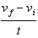 = 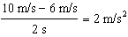

122. ANS:
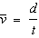
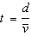
t = 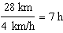

123. ANS:
Acceleration = 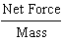, a =
a = 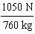 = 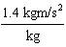 = 1.4 m/s²
a = 1.4 m/s² horizontally

124. ANS:
Weight = Mass Acceleration due to gravity
W = m g
W = 3.5 kg 9.8 m/s² = 34.3 kg·m/s²
W = 34.3 N

125. ANS:
Momentum = Mass Velocity
Momentum = 38 kg 2.2 m/s = 83.6 kg·m/s, downriver

126. ANS:
a =
F = m a = 0.3 kg 11 m/s² = 3.3 kg·m/s²
F = 3.3 N

127. ANS:


128. ANS:
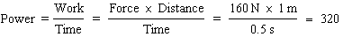 N·m/s = 320 J/s
Power = 320 J/s = 320 W

129. ANS:
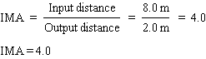

130. ANS:
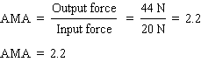

131. ANS:
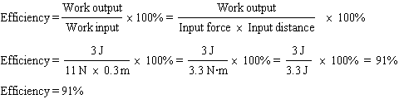

132. ANS:
225,000 J

OTHER

133. ANS:
The object moved a distance of 300 m in 8 s. The object’s average speed is 37.5 m/s.

134. ANS:
0 kg·m/s

135. ANS:
The momentums of both skaters are equal in size but opposite in direction.

136. ANS:
The push on Skater B by Skater A accelerates Skater B forward.

137. ANS:
According to Newton’s third law of motion, as Skater A pushes on Skater B, an equal and opposite force pushes back on Skater A. The unbalanced force causes Skater A to accelerate backward.

138. ANS:
No; only Circuit A is a series circuit. In Circuit A, the current can follow only one path through all three bulbs. Circuit B is a parallel circuit because the current can follow a separate path through each of the three bulbs.

