INSTRUCTIONS FOR LAB #7

Title: Found on page 2.

Abstract: Explain (A) why you did this lab; (B) what results you found in this lab, and (C) your percent error.

Introduction: Discuss what hydrated crystals mean. How are they different from regular crystals. Identify all purposes for the lab.

Methods and Materials: List your materials (page 2) and rewrite the procedure as instructed (past tense, impersonal, and complete sentences).

Results: Make a table showing mass of filter paper before the procedure, the mass of the system after it dries, and the difference of mass (thus the mass of the solid). Then, find the % error for your experiment. The formula is:

% error = (actual yield – theoretical yield)/theoretical yield * 100

Discussion: The bulk of your discussion should be your results, and your experimental error. Be sure to discuss what parts of the procedure could have resulted in your errors, as well as how you can correct them.

Literature Cited: Be sure to give proper credit. You should include the three at the end of the lab, and whatever you look up.
Composition of Hydrates Lab #7
Text reference: Chapter 7. pp. 154—159

INTRODUCTION:
A HYDRATED CRYSTAL or hydrate occurs when water becomes tightly attracted to a metal salt. The water molecules maintain integrity as molecules, however they are considered to be part of the formula of the hydrate. When the hydrated metal salt crystal is heated, the attractions to the water are broken by the heat energy and the water escapes from the crystal. After heating the salt crystal is called ANHYDROUS, meaning without water. Many of the salts contain transition metals such as copper or cobalt and therefore are colorful. Often the color of a transition metal hydrate will change as a function of how many waters it is attracted to. Hydrates are one of the few formulas to have a coefficient within.
Hydrates are ionic compounds (salts) that have a definite amount of water (water of hydration) as part of their structure. The water is chemically combined with the salt in a definite ratio. Ratios vary in different hydrates but are specific for any given hydrate.
The formula of a hydrate is represented in a special manner. The hydrate of copper sulfate in this experiment has the formula CuSO4 xH2O. The unit formula for the salt appears first, and the water formula is last. The raised dot means that the water is loosely bonded to the salt. The coefficient x stands for the number of molecules of water bonded to one unit of salt. This special formula, like all other formulas, illustrates the law of definite composition.
When hydrates are heated, the “water of hydration” is released as vapor. The remaining solid is known as the anhydrous salt. The general reaction for heating a hydrate is:

Hydrate → Anhydrous Salt + Water

The percent of water in a hydrate can be found experimentally by accurately determining the mass of the hydrate and the mass of the anhydrous salt. The difference in mass is due to the water lost by the hydrate. The percentage of water in the original hydrate can easily be calculated:
Percent H₂O = (mass H₂O / mass hydrate) x 100

In this experiment, as was mentioned, a hydrate of copper sulfate will be studied
(CuSO₄ · xH₂O).
The change from hydrate to anhydrous salt is accompanied by a change in color:

CuSO₄ · xH₂O (this is blue) → CuSO₄ + xH₂O (this is white)

This investigation should aid in the understanding of the formulas and composition of hydrates and the law of definite composition.

PURPOSE:
- Determine the percentage of water in a hydrate.
- To calculate how many moles of water are associated with one mole of a metal salt.
- To determine whether your Cupric Sulfate Hydrate may be the monohydrate with one mole of water attracted to the cupric sulfate, dehydrate (two moles), trihydrate (three moles), tetrahydrate (four moles) or pentahydrate (five moles).

MATERIALS:
evaporating dish, porcelain iron ring crucible tongs
wire gauze microspatula laboratory burner
laboratory balance safety goggles ring stand
lab apron or coat copper sulfate hydrate, CuSO₄ · xH₂O

SAFETY:
- Do not touch a hot evaporating dish with your hands. Use tongs
- Tie back long hair and secure loose clothing when working around an open flame. Be sure to wear a lab apron or coat and safety goggles when working in the lab.
- Be careful to avoid BURNS as a hot ring stand looks like a cool one! If your dish drops off of the ring stand during heating DO NOT TRY TO CATCH IT, let it fall. I would rather you break a dish than have you burn your hand.
- Do not wear gloves; they will melt from the heat. Should skin contact occur, flush thoroughly with water.
- Wear aprons and goggles and do not sit during the lab.

PROCEDURE:
1. Prepare the setup shown below:

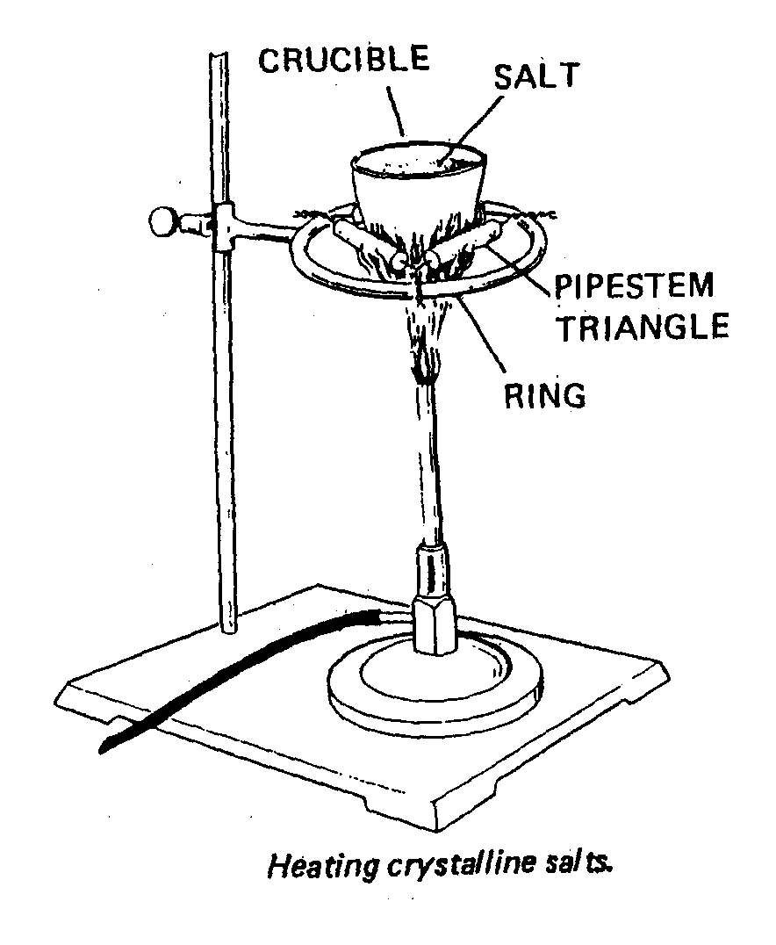
Figure 11-1

2. Heat the dish with the hottest part of the flame for 3 minutes.

3. Using crucible tongs, remove the evaporating dish from the apparatus. Place it on an insulated pad and allow it to cool for several minutes.

4. Find the mass of the evaporating dish to ±0.01 g. Record the mass in the Observations and Data section.

5. With the evaporating dish on the balance, measure into it exactly 2.00 g of copper sulfate hydrate. Record the data below.

6. Place the evaporating dish + hydrate on the wire gauze. Gently heat the dish by moving the burner back and forth around the base. Increase the heat gradually. Avoid any popping and spattering.

7. Heat strongly for 5 minutes or until the blue color has disappeared. During heating, a microspatula may be used to “spread” the solid and break up any “caked” portions of the hydrate. Be careful not to pick up any of the solid on the microspatula. If the edges of the solid appear to be turning brown, remove the heat momentarily and resume heating at a gentler rate.

8. Allow the evaporating dish to cool for about a minute. Immediately find the mass of the dish + anhydrous salt, and record the data below.

Observations and Data

A | Mass of crucible and lid OR mass of evaporating dish
B | Mass of crucible, lid and hydrated salt OR mass of evaporating dish + hydrate
C | Mass of hydrated salt (B-A)
D | Mass of crucible, lid and solid after heating OR mass of evaporating dish + anhydrous salt
E | Mass of anhydrous salt remaining after heating  (D-B)
F | Mass of water (lost from hydrated salt)  (C-E)
G | Moles of anhydrous salt *
H | Moles of water **
* Gram molecular weight of anhydrous salt X =159.5 g/mole
** Gram molecular weight of water = 18.0 g/mole

DATA QUESTIONS:

1. The true value for the percentage of water in this hydrate is 36.0%. What is your experimental error?

2. Why must you allow the evaporating dish to cool before measuring its mass?

3. Why must you measure the mass of the anhydrous salt immediately upon cooling?

4. Explain how your class’s results in this experiment support the law of definite composition.

5. Given the true mole masses of CuSO4 (160 g) and 1120 (18 g), how could you find the exact formula of the hydrate from your experimental data? That is, how could you find the value of x in the formula CuSO4 xH2O?

CITATIONS:

Caiafa, M. (2006). “Calculation of Water of Hydration.” Fresh Meadows, NY

Dorin, H., et al. (1989). Chemistry – The Study of Matter. Englewood Cliffs, NJ. Prentice Hall.

Wagner, M. (1989). Chemistry – The Study of Matter Laboratory Manual (Fourth Edition). Englewood Cliffs, NJ. Prentice Hall.

