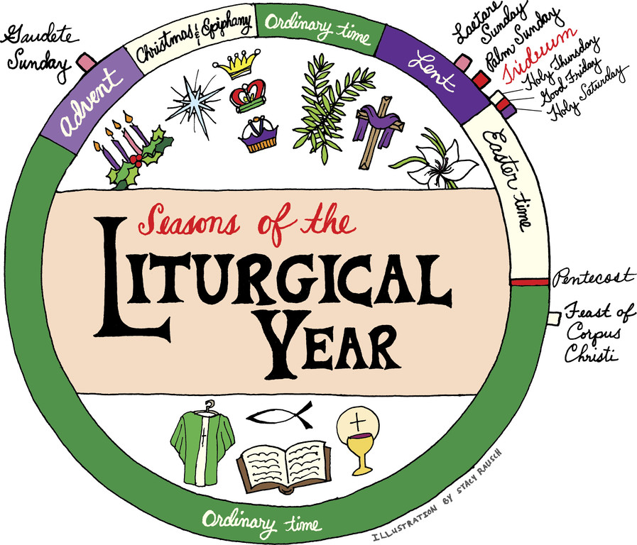
Fall wreaths of gold and crimson adorn front doors; red and green twinkling lights accent winter windowsills; and bouquets of purple irises and yellow daffodils stand tall and cheerful on springtime tables. As humans, we have the impulse to decorate and celebrate each season. We seek a visual way to acknowledge and rejoice in the changing weather and holidays, secular and sacred, that mark the calendar year.
The Catholic Church uses our senses - with the aroma of incense, the sounds of the choir, the images of the Nativity and the crucifixion - to draw us deeper into the cyclical mysteries of the liturgical seasons.
Colors are one way the church connects Catholics visually to a particular event or mystery. But from purple and rose Advent candles to a priest's green vestments, have you ever wondered why certain colors are used?
The choice is not random or simply decorative; it has specific meaning as the faithful move through the liturgical year or honor a special occasion or sacrament.
Colors have been part of the liturgy since the beginning of the church, according to Father Michael Witczak, associate professor of liturgical studies at Catholic University in Washington and past president of the North American Academy of Liturgy. The colors, each with its own significance, "emerged out of the fact that people like variety, and the origin of colors are rooted in the meaning of an individual season," Father Witczak said.
The first person to systematize the Roman Catholic color scheme was Pope Innocent III, pontiff from 1198 to 1216, who named four liturgical colors: white, red, black and green. The exact shade depended on what dyes were available at the time, and names for colors could differ, said Father Witczak.
The current six liturgical colors, which include rose and violet/purple, were codified in 1570 with the promulgation of the Roman Missal after the Council of Trent. Gold and silver are allowed on special occasions.
The liturgical year is punctuated with feast days, sacraments and other events that use colors outside the particular season. For example, red is used for the sacrament of confirmation and white for a nuptial Mass.
Some color variations are allowed based on tradition, according to Father Witczak. Dioceses in Spain and Mexico, and other nations of Spanish heritage, have been given permission to use the color blue for Marian feasts, including the feast of the Immaculate Conception. Blue also is granted to some Marian shrines.
"For people who go to church Sunday after Sunday, or day after day, the changing colors are a reminder that there's change happening in the church," said Father Witczak. "Most of us decorate our homes seasonally," and there's "a human naturalness of doing the same thing with liturgy," he said. Liturgical colors, he added, enrich our worship of God in a dignified way, with hues that are appropriate and beautiful.
In the Latin Church and other Western churches, the liturgical year begins with Advent, the fourth Sunday before Christmas.
Violet/purple
Symbolizes: penance, preparation, sacrifice
When used: Advent, Lent; may be used for funeral Masses. Purple originally was associated with royalty, because it was a more expensive color to dye, according to Father Witczak. Over time, it became associated with penance. "Some say it's more appropriate to use violet during Advent and a more reddish purple during Lent," Father Witczak said. The red, he explained, evokes the Lord's passion while the more bluish color calls to mind Mary's essential role in salvation history.
White
Symbolizes: purity, joy, light, glory
When used: Christmas and Easter seasons; Holy Thursday; the solemnity of the Most Holy Trinity; the feasts of Our Lord (excluding those relating to His passion), the Virgin Mary, the angels and the saints who are not martyrs; and the feasts of All Saints (Nov. 1), St. John the Baptist (June 24), St. John the Evangelist (Dec. 27), the Chair of St. Peter (Feb. 22) and the Conversion of St. Paul (Jan. 25). White is used at nuptial Masses and baptisms, and may be used at funerals. White also is allowed for days special to a given parish or region, such as a parish feast day or anniversary, or Thanksgiving Day in the United States, according to Father Witczak. Gold or silver also may be used for solemn occasions.
Green
Symbolizes: hope, life, anticipation
When used: Ordinary time, a season focused on the Lord's three-year public ministry, His teachings and miracles; a reminder that the mission of the church is to share the hope and life of Christ with the world.

Rose
Symbolizes: anticipation, rejoicing
When used: Gaudete Sunday (the third Sunday of Advent) and Laetare Sunday (fourth Sunday of Lent). Both "gaudete" and "laetare" are variations of "to rejoice" in Latin. The Sundays occur at the midpoint of Advent and Lent and are a reminder of the upcoming joyful events. They also offer a "change of tonality" within the respective seasons, said Father Witczak.
Red
Symbolizes: blood, fire, passion
When used: Representing blood, the church assigns this color to Palm Sunday, Good Friday, the celebration of the Lord's passion, the birthday feast days of apostles and evangelists, and the celebration of martyred saints. As a symbol of the Holy Spirit and the burning fire of God's love, red also is used on Pentecost Sunday, the sacrament of confirmation and the votive Masses of the Holy Spirit.
Black
Symbolizes: death, mourning
When used: Although not used frequently in the United States, it may be used at funeral Masses, the feast of All Souls or the anniversary of the death of a loved one. Following Vatican II, white is the preferred color since it reminds us of the Resurrection and our baptism.

Where are colors used?
Liturgical colors are used on sacred vestments, but they also can be used on banners, altar frontals, the ambo - a place in a Catholic Church from which Scripture is read and the homily often is given - and sometimes the veil over the chalice.
Sources: General Instruction of the Roman Missal; "The Color of Liturgical Vestments," a column from the Catholic Herald By Fr. William P. Saunders; U.S. Conference of Catholic Bishops; Boston Archdiocese

