Crime Scene Sketch

- Rough Draft
- Show all measurements (use a tape measure)
- Hand draw with a pencil
- Use feet and inches
- Use the principals and methods from class
- Include a North Arrow
- Include a Legend or Key: Victims name, address of the crime scene, the name of the person drafting the sketch, date, case number, and weather conditions.
- Label items with letters for furniture and numbers for evidence
- Create a crime scene
- Use the Exploded method to reveal blood spatters on a wall. (Use a measurement to show the distance from the floor)

- Finished “Smooth” Copy
- Include measurements but draw distances to scale.

- If you include a victim do not draw a stick figure. (Their height should be appropriate to the scale).
- Drafted in a neater form than the rough copy; use a pen and ruler to make lines.
- The Key /Legend (letters for furniture and numbers for evidence)
- Identify the scale that you used, a North Arrow, Victims name, address of the crime scene, and the name of the person drafting the sketch, date, case number, and weather conditions.
- Optional: Use a CAD computer or a website
(ie. www.smartdraw.com)

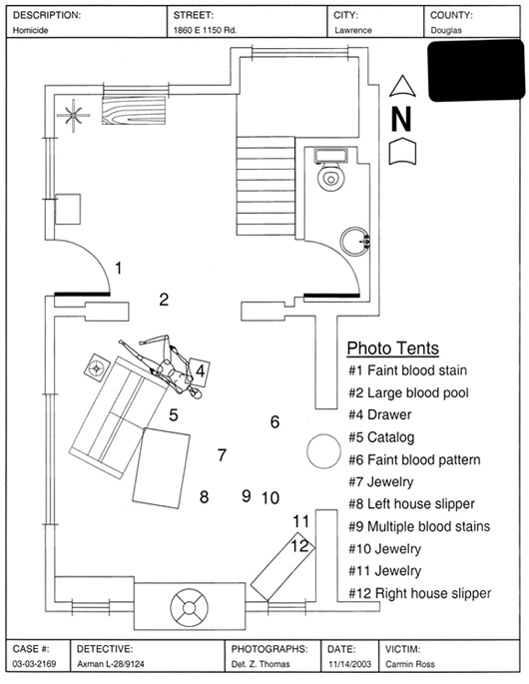

Video on processing a crime scene
http://www.videojug.com/interview/documenting-a-crime-scene-2

Sirchie Labs
http://www.sirchie.com/Assets/Manuals/pdf/TB100_TB03-175ENG.pdf
Brochure
http://www.eastchester.k12.ny.us/schools/hs/teachers/goldberg/documents/SirchieEvidenceCollection.pdf

